**CODE:**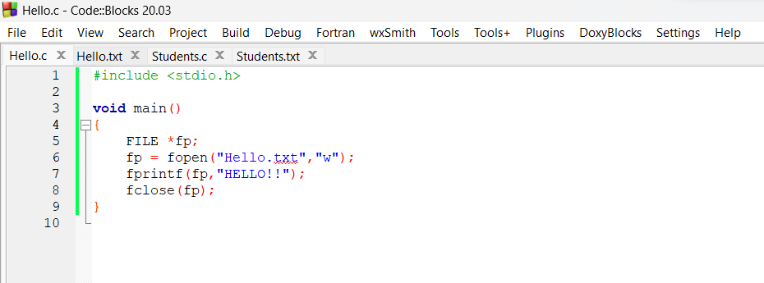

**OUTPUT:**

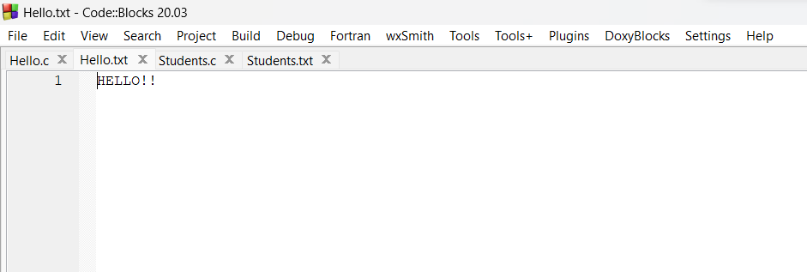

**CODE:** 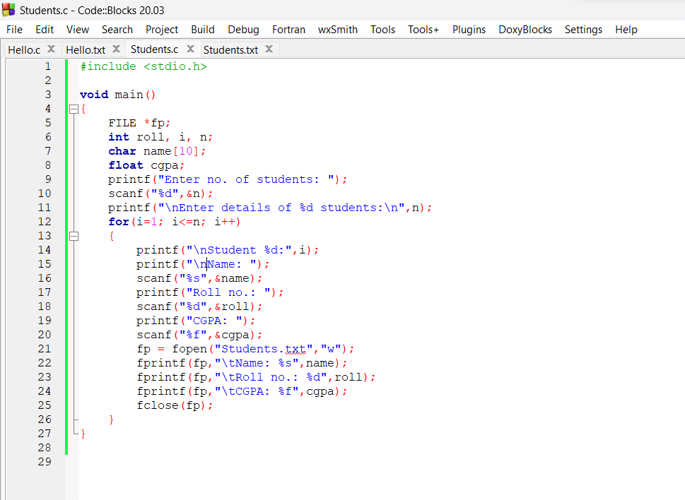

**OUTPUT:**

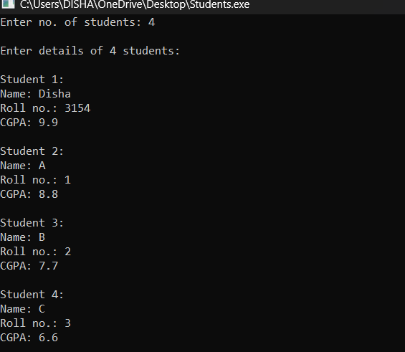

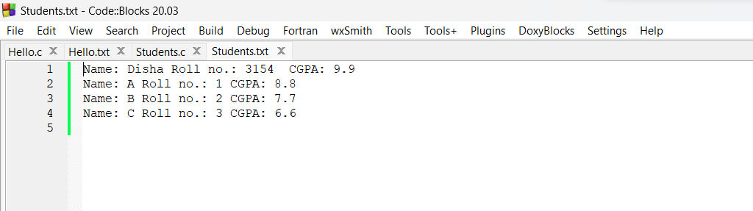

**CODE:**

#include <stdio.h>

#include <stdlib.h>

#include <string.h>

struct student

{

char name[50];

int roll;

float cgpa;

} s;

void insert()

{

FILE *fptr;

fptr = fopen("student.txt", "a");

printf("Enter name: ");

scanf("%s", s.name);

printf("Enter roll number: ");

scanf("%d", &s.roll);

printf("Enter cgpa: ");

scanf("%f", &s.cgpa);

fprintf(fptr, "%s %d %.2f\n", s.name, s.roll, s.cgpa);

fclose(fptr);

}

void display()

{

FILE *fptr;

fptr = fopen("student.txt", "r");

printf("\nName\tRoll Number\tcgpa\n");

while (fscanf(fptr, "%s %d %f", s.name, &s.roll, &s.cgpa) != EOF)

{

printf("%s\t%d\t\t%.2f\n", s.name, s.roll, s.cgpa);

}

fclose(fptr);

}

void search()

{

FILE *fptr;

fptr = fopen("student.txt", "r");

int rollNumber;

printf("Enter roll number to search: ");

scanf("%d", &rollNumber);

while (fscanf(fptr, "%s %d %f", s.name, &s.roll, &s.cgpa) != EOF)

{

if (s.roll == rollNumber)

{

printf("\nName\tRoll Number\tcgpa\n");

printf("%s\t%d\t\t%.2f\n", s.name, s.roll, s.cgpa);

fclose(fptr);

return;

}

}

fclose(fptr);

}

void update()

{

FILE *fptr1, *fptr2;

fptr1 = fopen("student.txt", "r");

fptr2 = fopen("temp.txt", "w");

int rollNumber;

float newcgpa;

printf("Enter roll number to update: ");

scanf("%d", &rollNumber);

while (fscanf(fptr1, "%s %d %f", s.name, &s.roll, &s.cgpa) != EOF)

{

if (s.roll == rollNumber)

{

printf("\nEnter new cgpa: ");

scanf("%f", &newcgpa);

fprintf(fptr2, "%s %d %.2f\n", s.name, s.roll, newcgpa);

}

else

{

fprintf(fptr2, "%s %d %.2f\n", s.name, s.roll, s.cgpa);

}

}

fclose(fptr1);

fclose(fptr2);

remove("student.txt");

rename("temp.txt", "student.txt");

}

void delete()

{

FILE *fptr1, *fptr2;

fptr1 = fopen("student.txt", "r");

fptr2 = fopen("temp.txt", "w");

int rollNumber;

printf("Enter roll number to delete: ");

scanf("%d", &rollNumber);

while (fscanf(fptr1, "%s %d %f", s.name, &s.roll, &s.cgpa) != EOF)

{

if (s.roll != rollNumber)

{

fprintf(fptr2, "%s %d %.2f\n", s.name, s.roll, s.cgpa);

}

}

fclose(fptr1);

fclose(fptr2);

remove("student.txt");

rename("temp.txt", "student.txt");

}

int main()

{

int choice;

while (1)

{

printf("\n1.INSERT 2.DISPLAY 3.SEARCH 4.UPDATE 5.Delete 6.Exit \nEnter your choice: ");

scanf("%d", &choice);

switch (choice)

{

case 1:

insert();

break;

case 2:

display();

break;

case 3:

search();

break;

case 4:

update();

break;

case 5:

delete();

break;

case 6:

exit(0);

default:

printf("Invalid choice.\n");

}

}

}

**OUTPUT:**

